
RAMAIAH
Institute of Technology
USN | 1 | M | S

(Autonomous Institute, Affiliated to VTU)
(Approved by AICTE, New Delhi & Govt. of Karnataka) Accredited by NBA & NAAC with ‘A’ Grade

SEMESTER END EXAMINATIONS – MAY/JUNE 2018

Course & Branch | : | B.E. : Electrical and Electronics Engg. | Semester | : | IV
Subject | : | Signals and Systems | Max. Marks | : | 100
Subject Code | : | EE43/EE403 | Duration | : | 3 Hrs

Instructions to the Candidates:
- Answer one full question from each unit.

 |  | UNIT- I
1. | a) | Explain: i. Periodic and Non Periodic signals  ii. Discrete and Continues time signals.  Find the even and odd components of the signal.  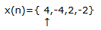 | CO1 | (08)
 | b) | Determine whether the system:  y(t)=0; t<0 = x(t)+x(t-100); t>=0 is Linear, time invariant, Causal, Memory less and stable. | CO1 | (08)
 | c) | A discrete time sequence h(n) is shown in Fig. 1(c).  Sketch the signal x(n)=h(3n).δ(n-1).  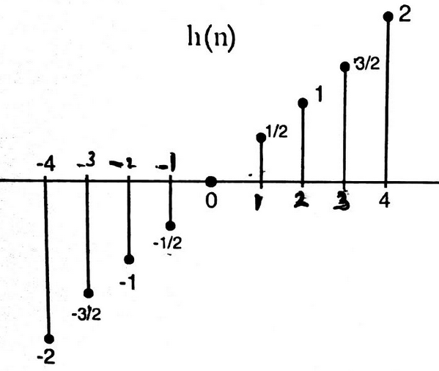  Fig.1(c) | CO1 | (04)
2. | a) | Define Even and Odd signals. Sketch x[n] and its odd and even parts where x[n]= 8(0.5)^{n}u(n). | CO1 | (08)
 | b) | i) Given y(t)= [cos(3πt)]², Check for periodicity.  ii) Given y (t) = x (t) + 2 x (3-t), check for causality.  Identify the value of t, if any, where the system will change its status from Causal to Non-causal. | CO1 | (06)
 | c) | Define Power and Energy signals. Determine whether the signal shown in the Fig. 2(c) is a power signal or energy signal. Justify your answer and further determine its energy or power.  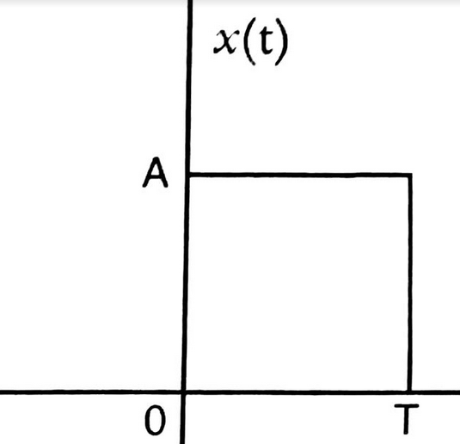  Fig.2(c) | CO1 | (06)
 |  | UNIT- II
3. | a) | Compute y(t)=h(t)*x(t) for h(t)= (1/2) u[t] and x(n)= 2u[-t]. | CO2 | (10)
 | b) | Obtain the Convolution sum of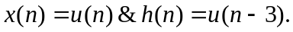 | CO2 | (10)
4. | a) | Convolute the two continuous time signals x(t)= u(t) and h(t)= t u(-t) | CO2 | (10)
 | b) |  | CO2 | (10)
  Compute the convolution of two sequences x₁(n) and x₂(n),
  given below x₁(n)={ 1,2,3} and x₂(n)={ 1,2,3,4}
 |  | UNIT- III
5. | a) | Find the complete response of the system described by the difference equation y(n)- (1/9) y(n-2) = x(n-1) with y(-1)=1, y(-2)=0 and x(n)=u(n). | CO3 | (10)
 | b) | Draw the direct form I and II implementations of the system represented by the differential equation / difference equation  - 3y(t)+2 dy(t)/dt +d³y(t)/dt³ = x(t) +3dx(t)/dt  - y(n) + (¹/₂ )y (n-1) -(¹/₃ ) y(n-3) = x(n) + 2x(n-2) | CO3 | (10)
6. | a) | Find the natural and forced response of the system given by the difference equation y(n)-1.5y(n-1)+ 0.5y(n-2) = x(n) with input x(n)= 2^{n}u[n], y(-1)=1, y(-2)=0. | CO3 | (10)
 | b) | Define natural and forced response of an LTI system. Find the forced response of the system given by the differential equation  d²y(t)/dt²+ 9y(t) = x(t), where x(t)=cos 4t | CO3 | (10)
 |  | UNIT- IV
7. | a) | Determine the DTFS of the signal 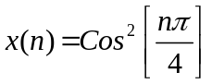 . | CO4 | (06)
 | b) | Write the modulation and convolution properties of DTFS and DTFT. | CO4 | (04)
 | c) | Determine the response of the LTI system whose input x(n) and impulse response h(n)are given by x(n)={1,2,3,1} and  h(n)={ 1,2,1,-1} using Discrete Time Fourier Transform. | CO4 | (10)
8. | a) | List out the properties of DTFT. Determine the DTFT of the signal 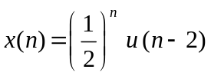 | CO4 | (10)
 | b) | Determine the DTFT of the following signals:  - 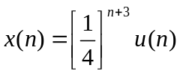 ii) 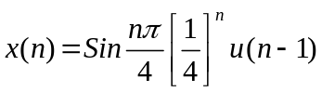 | CO4 | (10)
 |  | UNIT- V
9. | a) | Find the Z transform and ROC of: i) x(n)=(-1)^{n} 2^{-n} u(n)  ii) x(n)= [4 (3)^{n} - 3(5)^{n} ]u(n). | CO5 | (08)
 | b) | Solve the following difference equation using unilateral Z Transform:  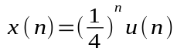  with initial conditions y(-1)=4,and y(-2) = 10. | CO5 | (12)
10. | a) | A causal discrete time LTI system has to be designed with the property that if the input 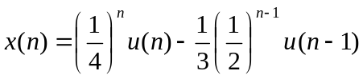, the corresponding output should be y(n)= (1/3)^{n}u(n). Determine the impulse response h(n) and the transfer function H(Z) that satisfies this condition. | CO5 | (10)
 | b) | List the properties of ROC. Also explain the time shifting and convolution properties of Z-transform. | CO5 | (10)
****************

